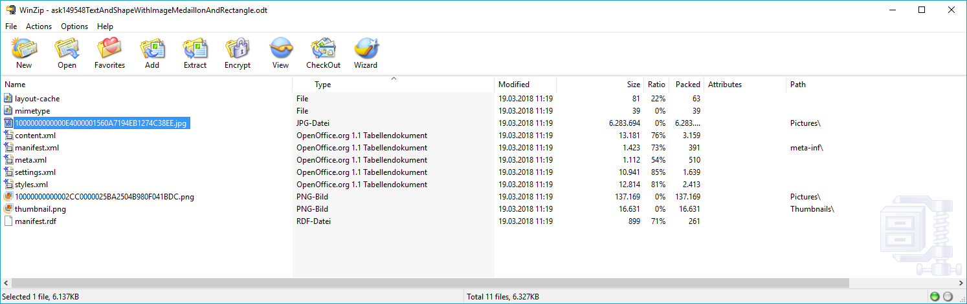
You see, the image was only embedded once. (The .png contains the copy of the 'Area' dialog I also inserted.)

The selection showing the usable graphics in the 'Area' dialog may not contain my image on your system because it wsn't added there. How to get it offered in this case I don't know, but anyway you will add the images of your choice yourself.

